**Programming challenges**

**3.3 Write a program that asks the user to enter their monthly costs for each of the following  
housing related expenses:**

**• rent or mortgage payment  
• utilities  
• phones  
• cable  
The program should then display the total monthly cost of these expenses, and the total  
annual cost of these expenses.**

**3.4 How Much Insurance?  
Many financial experts advise property owners to insure their homes or buildings for at  
least 80 percent of the amount it would cost to replace the structure. Write a program that  
asks the user to enter the replacement cost of a building and then displays the minimum  
amount of insurance that should be purchased for the property.**

**3.7 Average Rainfall  
Write a program that calculates the average monthly rainfall for three months. The  
program should ask the user to enter the name of each month, such as June or July, and the  
amount of rain (in inches) that fell that month. The program should display a message  
similar to the following:  
The average monthly rainfall for June, July, and August was 6.72 inches.**

**3.11**

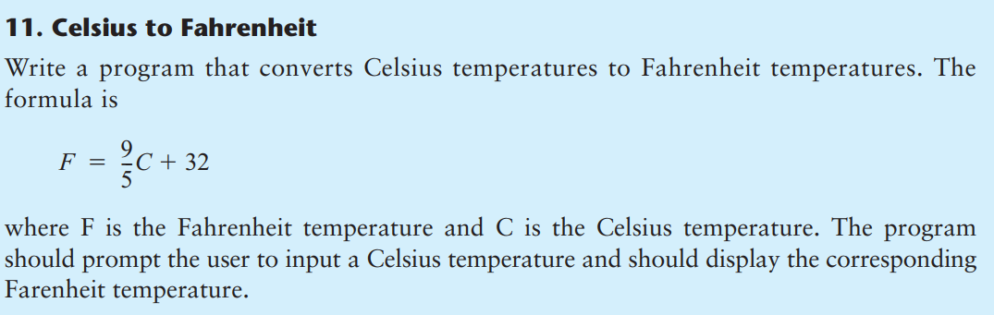

**3.13**

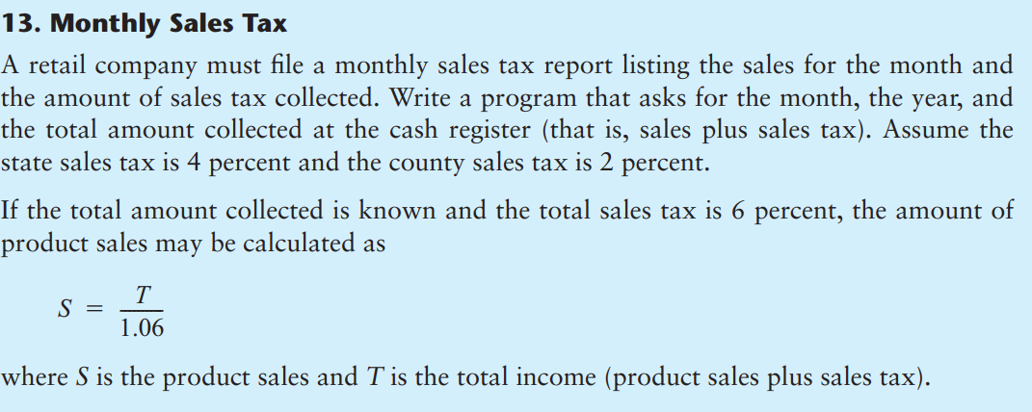

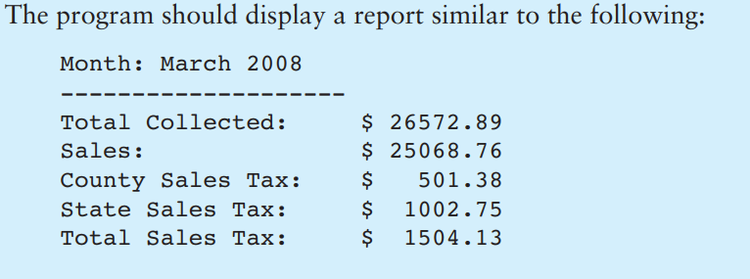

**3.18**

